AI Fitness Trainer

*Progress Report #9*

# TL; DR

**On track (*Github:***[*AI-FitnessTrainer*](https://github.com/aminuabdusalam/AI-FitnessTrainer)*)***.** Added **speech-to-text** and **text-to-speech** for user to choose exercise and for program to call out the counts by **10/30.**

# Project Goals (Recap)

The goal of the project can be summarized as developing an **AI fitness trainer** embedded with **storage and recommender systems** and an **AI virtual mouse**.

The AI fitness trainer will help the user lose weight, gain muscle, and accomplish other fitness goals. In addition, it'd attempt to understand the client goals, develop a fitness routine, recommend a healthy eating plan, and ensure all exercises are performed correctly.

# Highlights

**Added speech** speech-to-text and text-to-speech for user to choose exercise and for program to call out the exercise count ([Added text2speech et speech2text](https://github.com/aminuabdusalam/AI-FitnessTrainer/commit/f14ecac6029b149be4b33eff10f6768eadba6d1c) et [Used txt2speech & speech2txt in choice & counts](https://github.com/aminuabdusalam/AI-FitnessTrainer/commit/2a85d2b7f75ce73765d728030e5227df5e628cb4))

* Utilized **GTTS** (Google Text-to-Speech) library to convert text-to-speech by interfacing with Google Translate text-to-speech API.
* Leveraged the **playsound** module to play audio.’
* Made use of the speech_recognition module
  + Initialized the speech recognizer.
  + Used the **Microphone** class to enable audio input via pc microphone.
  + Used **adjust_for_ambient_noise** method for removing ambient noise.
  + Used **record** method to read the audio data from the default microphone for a duration of 5 seconds.
  + Finally, utilized **recognize_google** method to convert speech to text.
* Utilized the program in a live exercise session conducted by me as shown below.

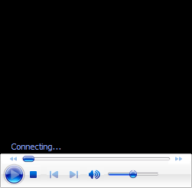

* As shown below, trainer now works for all of **curls**, **pushups, and squats**:

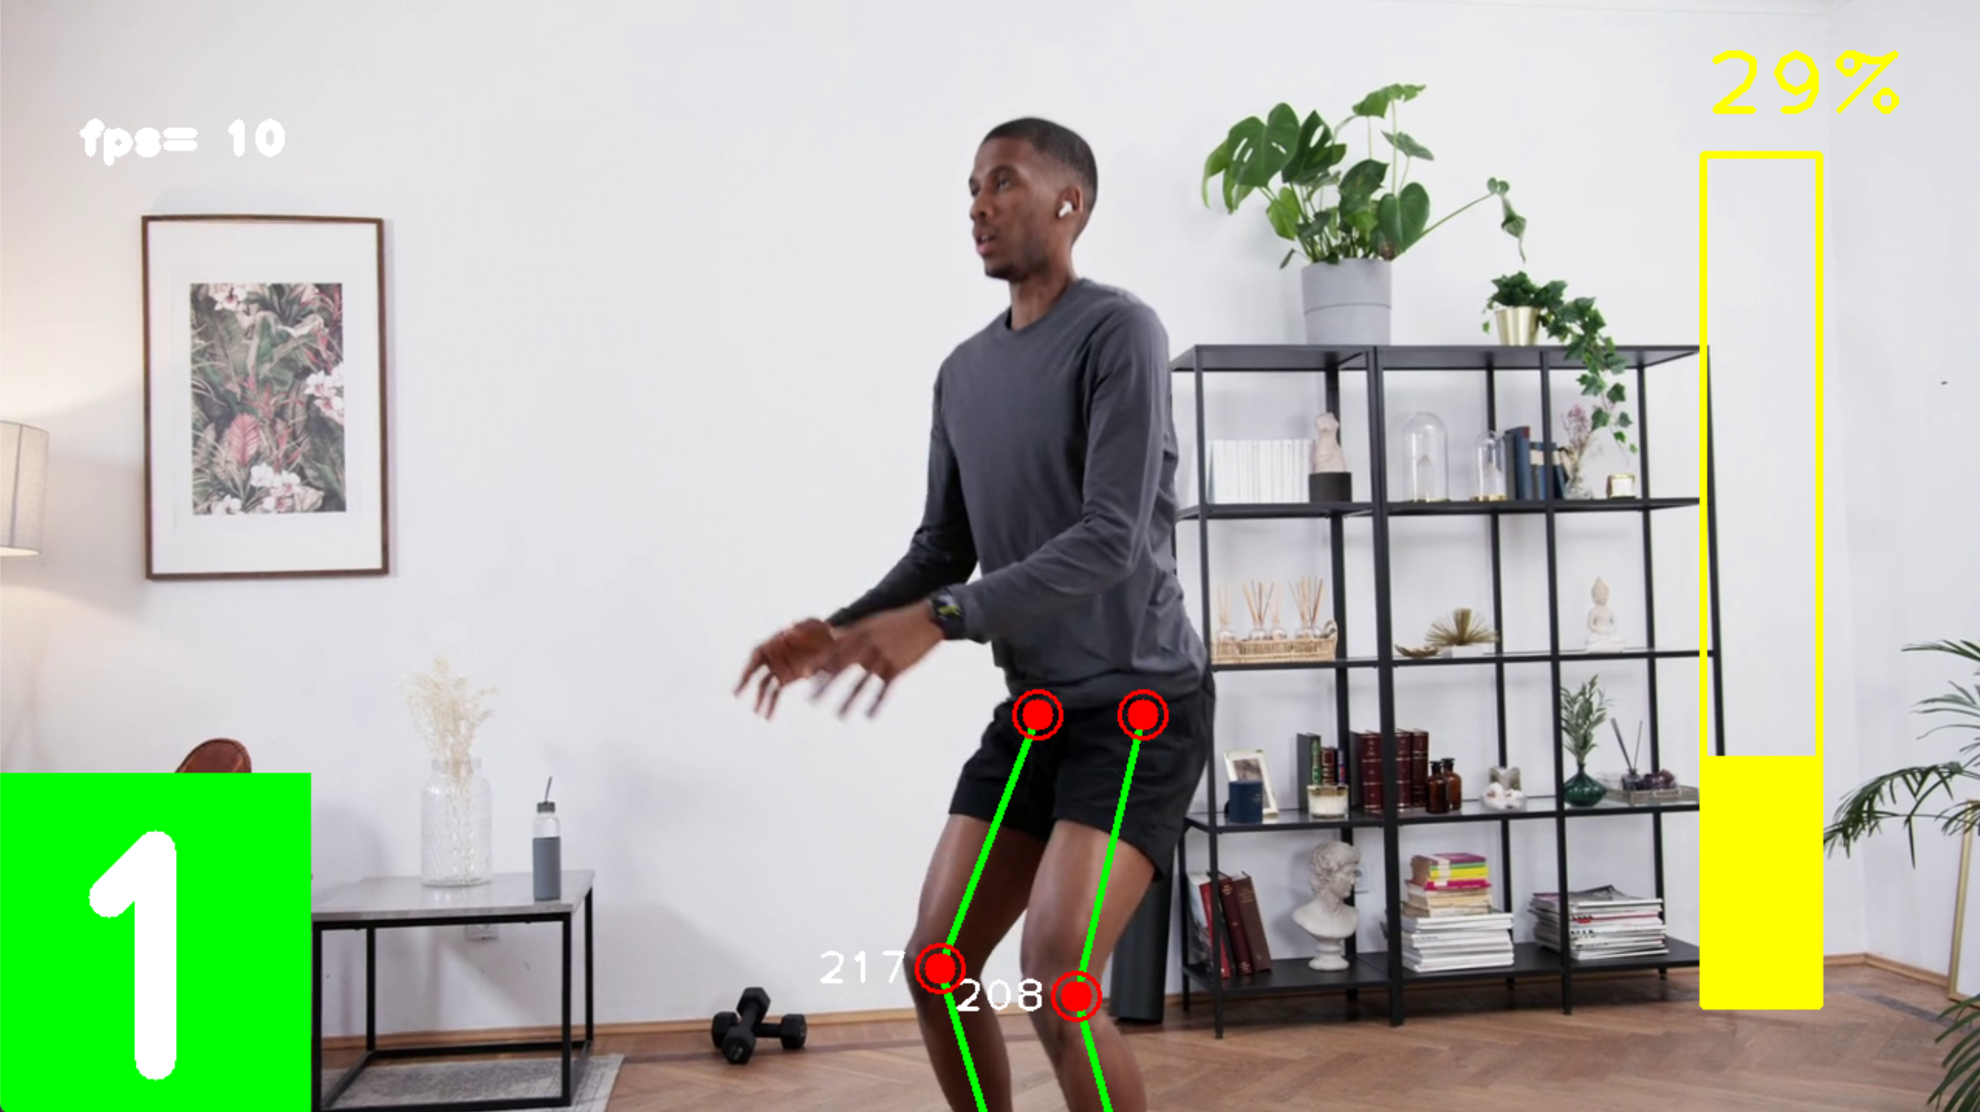

# Lowlights

None

# Next Steps

* Implement threading to allow trainer and audio processes to run in parallel by **11/7.**
* Complete testing and appropriate error handling by **11/7.**

# Timeline

This section lists the milestones of the project spread across two semesters (Fall 2022 and Spring 2023).

|  |  |  |  |
| --- | --- | --- | --- |
| **Milestones** | | **ETA** | **Status** |
| **Requirements Gathering** (Project Idea, Project Proposal) | | 08/22 | Completed |
| **Design Exploration** (Setup and Installation of necessary technologies, Addition of Project to remote repo, Skill Preparation, Framework Project) | | 08/29 | Completed |
| **Implementation** | Complete Pose Estimation Build | 09/19 | Completed |
| Complete AI Personal Trainer for **Curls** | 10/11 | Completed |
| Complete AI Personal Trainer for **Pushups** | 10/18 | Completed |
| Complete AI Personal Trainer for **Squats** | 10/25 | Completed |
| Complete speech-to-text et text-to-speech | 10/31 | **Completed** |
| **Quality Testing** | | 11/7 |  |
| **Midpoint Presentation Draft** | | 11/14 |  |
| **Midpoint Demo & Report** | | 11/21 |  |
|  | **WINTER BREAK** | | |
| **Project Review** (Current status and Re-evaluation of Next Steps as Needed) | | 01/16 |  |
| **Implementation** | Complete Storage System Build | 01/30 |  |
| Complete Recommender System Build | 02/20 |  |
| Complete Frontend/Website (Stretch Goals) | 03/13 |  |
| Complete Hand Tracking Build (Stretch Goals) | 03/13 |  |
| Complete AI Virtual Mouse Build (Stretch Goals) | 03/27 |  |
| **Quality Testing** | | 04/3 |  |
| **Final Presentation Draft** | | 04/10 |  |
| Final Demo & Report | | 04/17 |  |